# Soil moisture sensor

**How Does It Work?**

The soil moisture sensor consists of two probes which are used to measure the volumetric content of water. The two probes allow the current to pass through the soil and then it gets the resistance value to measure the moisture value.

[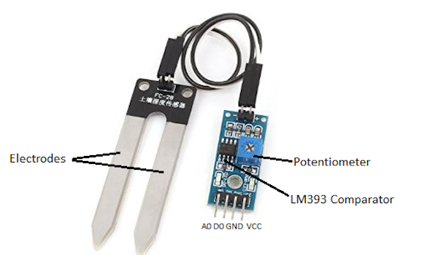](https://301o583r8shhildde3s0vcnh-wpengine.netdna-ssl.com/wp-content/uploads/2017/03/LM293-comparitor-pinout.jpg)

When there is water, the soil will conduct more electricity which means that there will be less resistance. Therefore, the moisture level will be higher. Dry soil conducts electricity poorly, so when there is less water, then the soil will conduct less electricity which means that there will be more resistance. Therefore, the moisture level will be lower.

**Applications and Specifications**

The specifications of the FC-28 soil moisture sensor are as follows:

* Input Voltage: 3.3 – 5V
* Output Voltage: 0 – 4.2V
* Input Current: 35mA
* Output Signal: Both Analog and Digital
* Use: Irrigation systems

# Connections

Sensor pins: The FC-28 soil moisture sensor has four pins:

* VCC: Power
* A0: Analog Output
* D0: Digital Output
* GND: Ground

The following pins are connected to the Arduino:

|  |  |
| --- | --- |
| Arduino pins | Sensor Pin |
| 5V | Vcc |
| GND | Gnd |
| Analog 0 | A0 |

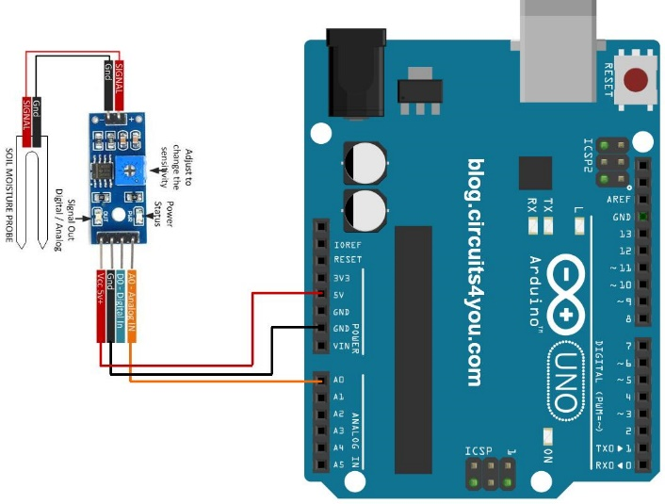

Library required for working of distance sensor: NONE

**Errors and Troubleshooting**

1. **If the values are zero or 1023, the output is correct, to verify insert the probe in soil with moisture and without moisture to get varied values**
2. **If you are getting no readings, check your wiring. The error is almost always there**
3. **Check baud rate if the serial monitor indicates weird readings.**